Celonis platform in Action

# Product solution options you'd like to explore further.

Once you've completed the Celonis Kickstarter course, go ahead and dive into more detail with courses dedicated to each product solution.

Now take your pick of which solution interests you:

## Analyses for all

Navigate Celonis Analyses and uncover value opportunities.

Celonis Analysis structures and visualizes data for you. Additionally, it equips you with the tools to explore process performance. Celonis surfaces inefficiencies and calculates the impact on your business based on standard or custom metrics.

Click on the visual below to learn more

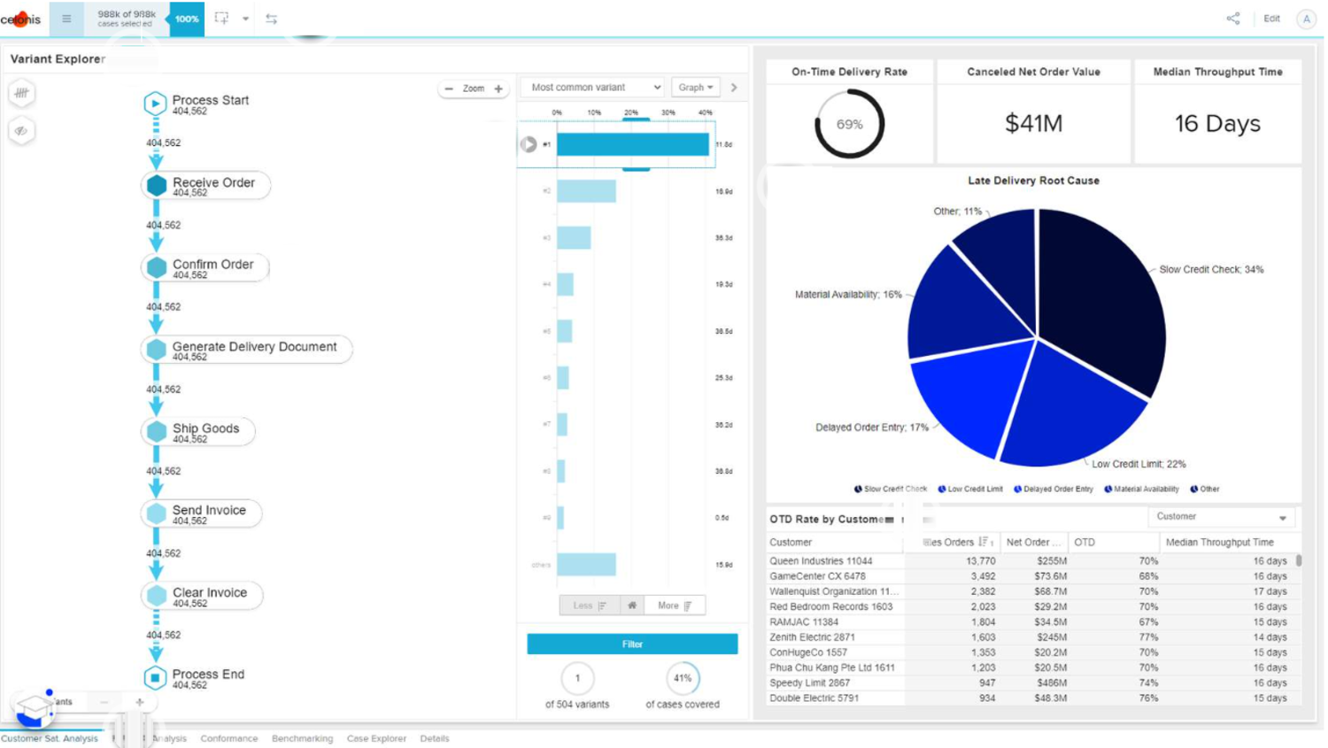

](https://academy.celonis.com/?wvideo=6t7r6uj7ye)

[O2C Analysis Video](https://academy.celonis.com?wvideo=6t7r6uj7ye)

## OCPM Basics

Use Object-centric Process Mining to reflect the reality of business processes.

## Business Miner

Harvest insights in a guided process exploration and drive faster alignment.

## Celonis Apps

Prioritize tasks and recommend actions.

## Action Flows

Automate your processes with Action Flows